Camel Music

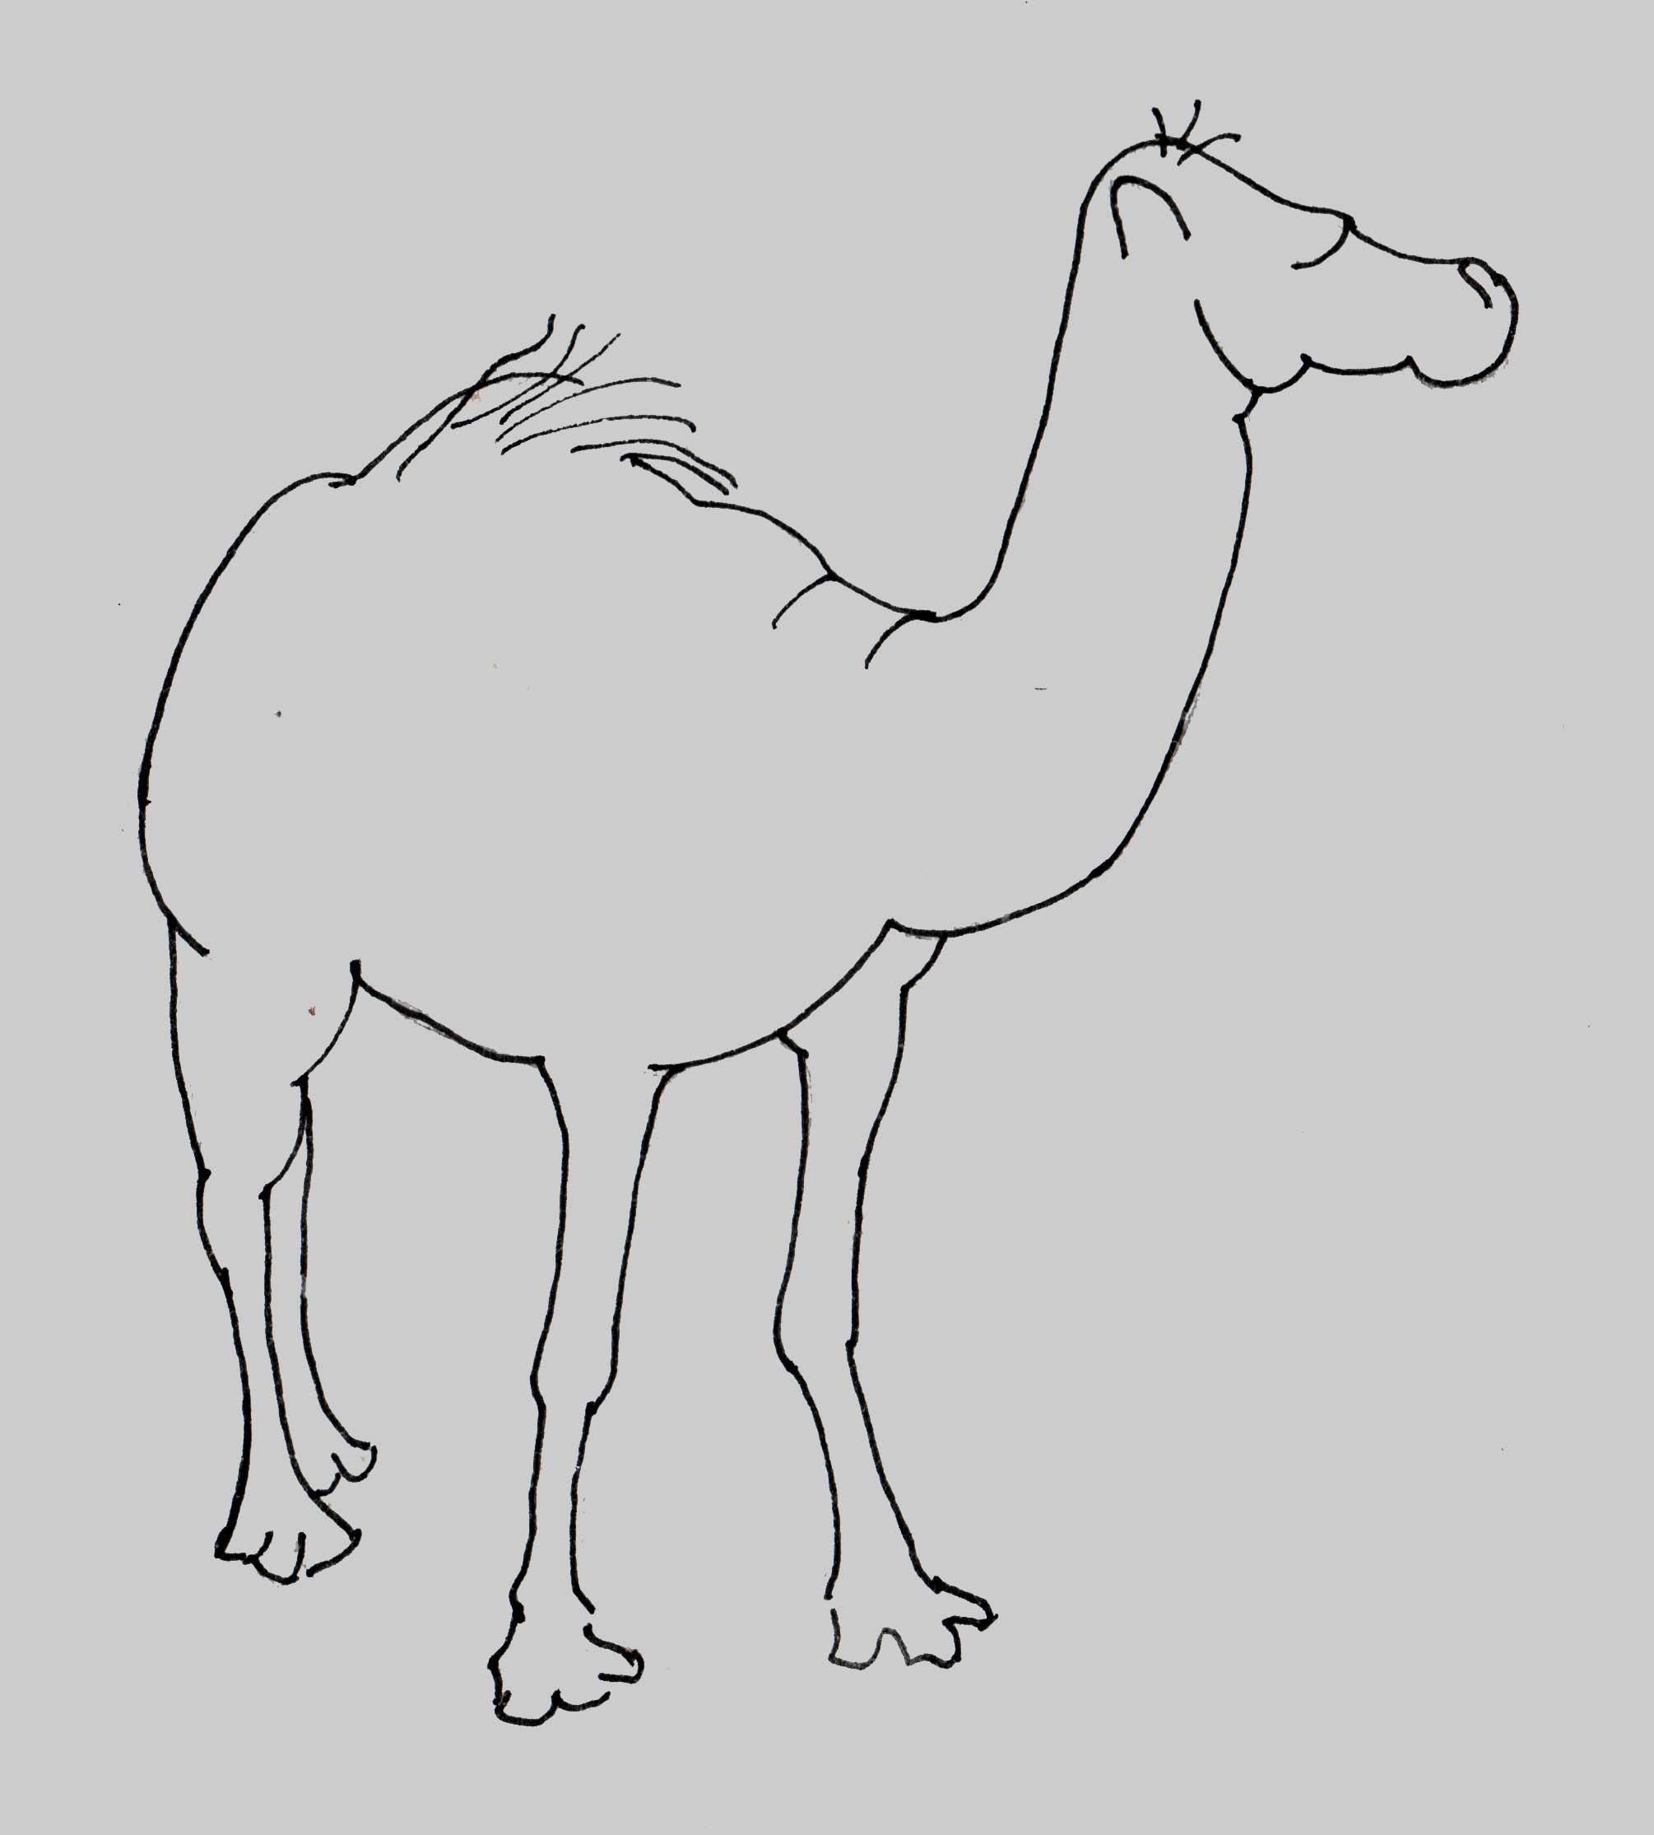

Ann Hamerton

Rain
(No. 2 from Alpine Sketches)

for viola and piano

CM062

